CS 434 Final Project: VPN
Clayton Davis and Brandon Denton

Creating a Host-to-Host Tunnel using TUN/TAP

Create a Host-to-Gateway Tunnel

Create a Gateway-to-Gateway Tunnel

Create a VPN

Authentication and Key Exchange
When the user starts up a client, it generates its own public key for the handshake with the VPN gateway, as shown below. This function within the client code, tls_client.c, executes immediately after a connection with the VPN is established for authentication.
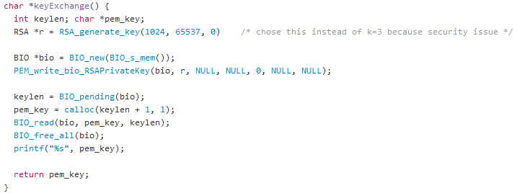

Supporting Multiple VPN Tunnels

